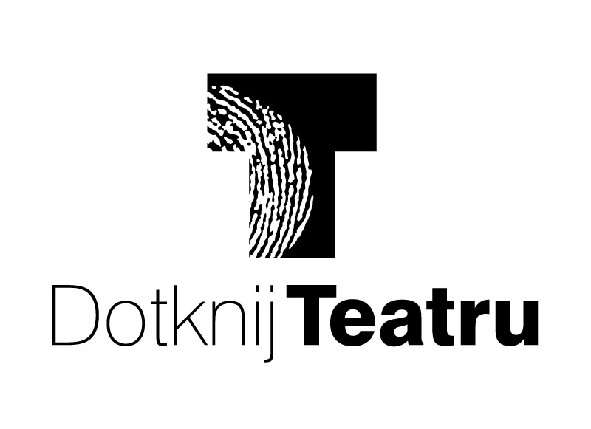

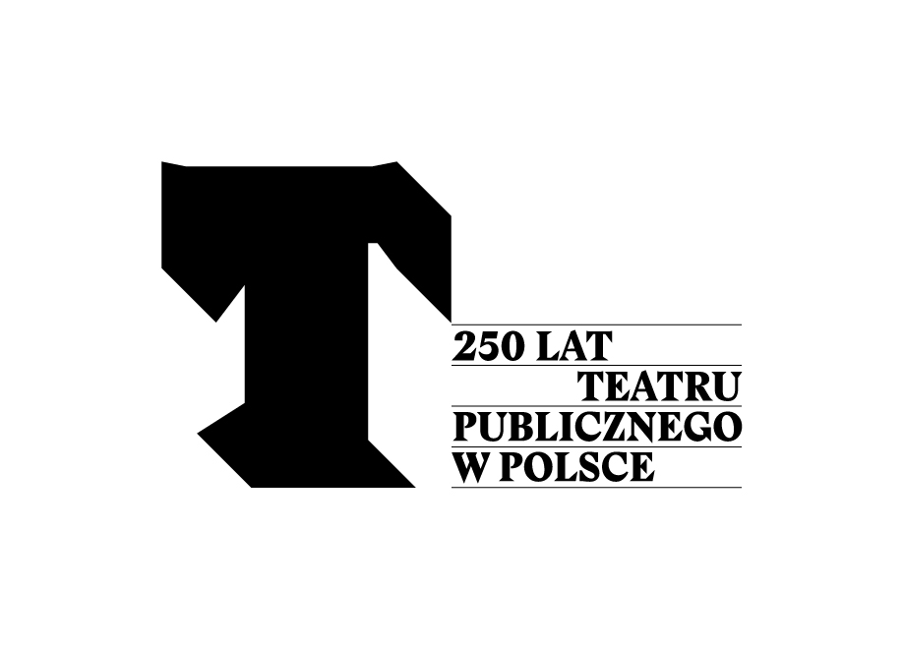
WORLD THEATRE DAY [27 March 2015]
This year World Theatre Day is celebrated for the 54th time. This celebration was initiated by the International Theatre Insititute (ITI) in 1961 to commemorate the inauguration of the Theatre of Nations in Paris in 1957 – a festival where theatre companies from both sides of the Iron Curtain met.
This year’s WTD is for us particularly important for several reasons. First of all, since the author of the message addresed to the whole “theatre world” is the Polish artist Krzysztof Warlikowski, director and head of the New Theatre in Warsaw. Secondly, celebrations of the World Theatre day go hand in hand with the jubilee of 250 YEARS OF PUBLIC THEATRE IN POLAND.
WORLD THEATRE DAY MESSAGE:
The true masters of the theatre are most easily found far from the stage. And they generally have no interest in theatre as a machine for replicating conventions and reproducing clichés. They search out the pulsing source, the living currents that tend to bypass performance halls and the throngs of people bent on copying some world or another. We copy instead of create worlds that are focused or even reliant on debate with an audience, on emotions that swell below the surface. And actually there is nothing that can reveal hidden passions better than the theatre.
Most often I turn to prose for guidance. Day in and day out I find myself thinking about writers who nearly one hundred years ago described prophetically but also restrainedly the decline of the European gods, the twilight that plunged our civilization into a darkness that has yet to be illumined. I am thinking of Franz Kafka, Thomas Mann and Marcel Proust. Today I would also count John Maxwell Coetzee among that group of prophets.
Their common sense of the inevitable end of the world—not of the planet but of the model of human relations—and of social order and upheaval, is poignantly current for us here and now. For us who live after the end of the world. Who live in the face of crimes and conflicts that daily flare in new places faster even than the ubiquitous media can keep up. These fires quickly grow boring and vanish from the press reports, never to return. And we feel helpless, horrified and hemmed in. We are no longer able to build towers, and the walls we stubbornly construct do not protect us from anything—on the contrary, they themselves demand protection and care that consumes a great part of our life energy. We no longer have the strength to try and glimpse what lies beyond the gate, behind the wall. And that’s exactly why theatre should exist and where it should seek its strength. To peek inside where looking is forbidden.
“The legend seeks to explain what cannot be explained. Because it is grounded in truth, it must end in the inexplicable”—this is how Kafka described the transformation of the Prometheus legend. I feel strongly that the same words should describe the theatre. And it is that kind of theatre, one which is grounded in truth and which finds its end in the inexplicable that I wish for all its workers, those on the stage and those in the audience, and I wish that with all my heart.
[Krzysztof Warlikowski]

AWARDS OF THE POLISH ITI CENTRE
On the occasion of the 54th World Theatre Day, the Polish Centre of the International Theatre Institute once again awarded the prize for outstanding efforts and work for the Polish theatre. The jury (composed of Zenon Butkiewicz - Ministry of Culture and National Heritage, Dariusz Kosinski - Zbigniew Raszewski Theatre Institute, Lech Sokółl and Barbara Osterloff - Polish Centre of the International Theatre Institute and Agnieszka Koecher-Hensel - representative of the Board of the Polish Centre of the International Theatre Institute) unanimously found that the 2015 STANISŁAW IGNACY WITKIEWICZ award - for outstanding achievements in promoting Polish theatre culture in the world should go to Darja Dominkuš - playwright at the Slovene National Drama Theatre in Ljubljana.
***
This year’s laureate has for thirty years been translating and promoting Polish literature in Slovenia. She translated among others plays by Stanisław Ignacy Witkiewicz, Sławomir Mrożek, Andrzej Mularczyk, Janusz Głowacki, Henryk Bardijewski, Dorota Masłowska, Marcin Pałasz and essays by Jan Kott.
Darja Dominkuš’s interest in Polish authors found its reflection in numerous articles and essays about Emil Korytka [Pregnan v Ljubljano (Sent into exile to Ljubljana), Gledališki list SNG Drama Ljubljana 1984/85], Stanisław I. Witkiewicz [O zgodovini, politiki in revoluciji (On history, politics and revolution), Gledališki list PDG Nova Gorica 1983/84, št. 3/16; Črna utopija v Čisti Obliki (Black utopia in Pure Form), Gledališki list Mestnega gledališča ljubljanskega, letnik XXXVI/1, sezona 1986/87; »Ta pustoš naših dana! Čime, da je ispunim?« (»The emptiness of our days! What to fill it with?«), Iz dijela, Cekade, Zagreb 1985; Theatrum mundi v čevljarski delavnici (Theatrum mundi in a shoemaker’s workshop), Dramatikon 1, Študentska založba, Ljubljana 1999; (Ne)identificirani ostanki človeštva ((Un)identified remnants of humanity), Gledališki list SNG Drama Ljubljana 2012/13, XCII/2], Sławomir Mrożek [Pogum za Tango (Courage to Tango), Dramatikon 2, Študentska založba, Ljubljana 2000], Janusz Głowacki [Globalne iluzije in lokalne depresije (Global illusions and local depressions), Gledališki list SNG Drama Ljubljana LXXXI/11, 2001/02], Dorota Masłowska [Mala kovinska Evropejka (Small metal European), Gledališki list SNG Drama Ljubljana XCII/4, 2012/13].
Darja Dominkuš was born on 20 July 1959 in Kranj (Slovenia, Yugoslavia). She graduated in drama at the Academy of Theatre, Radio, Film and Television and the Institute of English at the Faculty of Philosophy of the University of Ljubljana, where she also attended Polish language course at the Faculty of Slavic Studies. After studies, she was a freelancer for several years, and since 1986 has worked as a playwright at the Slovenian National Drama Theatre in Ljubljana (SNG Drama Ljubljana). She collaborated on staging over 70 productions.
***
This year, the prize of the Section of Theatre Critics of the Polish Centre of ITI for popularisation of Polish theatre culture abroad was awarded to Janina Szarek - Polish actress and director working in Berlin.
***
Janina Szarek is a graduate of the Ludwik Solski Academy for the Dramatic Arts in Krakow. Her professional career began in the STU Theatre, and later she worked with Krystian Lupa in Jelenia Góra and played in the Contemporary Theatre in Wrocław. Since 1981, she has been living in Berlin.
For several years she studied acting, working with Henryk Baranowski’s Transformtheater and Andrzej Woron’s Caricature Theatre. She played many roles in German films, lectured at Frei Universität Berlin and other theatre schools until she founded her own acting school - Transform - in a wealthy Charlottenburg district. In 2004, she established there the Polish-German scene "Tadeusz Różewicz Bühne am Salzufer", where she presented his dramas: White Marriage, The Old Lady Sits Waiting, The Card Index. Other Polish plays were also among her thirty premieres. Recently, she staged Angels and Pigs in Berlin by the younger generation prose writer Bridget Helbig, who worked at the University of Szczecin and currently teaches at the Humboldt University and the Polish-German University Viadrina. Her books have been twice nominated for the Nike Award (2011 and 2013).
Janina Szarek’s school and theatre attract Polish and German intelligentsia and artists. She cooperates with the Warsaw Academy of Theatre, the Contemporary Theatre in Szczecin, the Ludowy Theatre in Krakow.
Section of Theatre Critics of the Polish Centre of ITI came to the conclusion that both the “artistic level of performances, as well as many years of Janina Szarek’s work promoting Polish drama and theatre ideas” deserve acknowledgement and appreciation.
***
The title of the Theatre Book of the Year 2014 was granted to the work of Beata Guczalska: AKTORSTWO POLSKIE. GENERACJE (POLISH ACTING. GENERATIONS) (Ludwik Solski Academy for the Dramatic Arts, Kraków 2014).
The book is a monograph presenting changes of the Polish art of acting in the years 1945-2013. The selected period encompasses extremely diverse phenomena, including the work of outstanding personalities. The author analyzes and describes transformation of the style of acting of various generations Polish theatre during the period.

The aim of that Pan-Polish project is to create opportunities of creative encounters of theatre artists and spectators. Program “Touch the Theatre” has been accompanying the Polish part of the World Theatre Day celebrations since 2010. Five years ago, it was organized for the first time by Grupa Inicjatywna (Initiating Group) from Łódź. Almost in parallel to that the project of the Theatre Institute “Go to theatre!”, with similar aims, was developed in Warsaw. Therefore, it was decided to join the forces and to encourage other regions to participate in “Touch the Theatre”.
In 2012, we celebrated together in the Łódź, Greater Poland, Silesia and Masovian provinces. Two years later, we organized several hundred events in 49 cities all over Poland.
This year’s, sixth, edition of the program, will be participated by cultural institutions and artists from 53 Polish cities and towns (including the biggest cities: Warsaw, Kraków, Łódź, Wrocław or Poznań – and smaller towns: Otrębusy, Gronowo Górne, Choroszcz, Ruda-Huta).
Approximately 500 events will take place as part of “Touch the Theatre”, including readings, discussions, meetings with authors, concerts, performance, projections, stagings (over 200), workshops (approx. 100), as well as vernissages, lectures, exhibitions and organized tours of “theatre backstage”.
The events vary among different regions, and the diversity results from characteristics of a given region and financial capabilities. Common denominator of all “Touch the Theatre” projects is the fact that they “directly address the audience”, and participants of the events prepared by artists often get a chance to go to a place that would normally by inaccessible to them.
For a theatre, participating in the initiative means organizing a special event, for instance a workshop, meeting, tour around the theatre, or providing free invitations (or tickets at a promotional price) for performances or other repertoire events.
All projects and events planned as part of “Touch the Theatre” on the occasion of the World Theatre Day constitute part of celebrations of the 250 YEARS OF PUBLIC THEATRE IN POLAND, organized by the Ministry of Culture and National Heritage, and coordinated by the Zbigniew Raszewski Theatre Institute.
“Touch the Theatre 2015” will take place between 27 March and 3rd April.

Selected events of “Touch the Theatre 2015” (POLAND):
Łódź (almost 100 “Touch the Theatre” events – the highest number in the whole country). A review of Tadeusz Kantor’s performances recorded for TV will take place in the Museum of Cinematography, and premiere of „Melancholia/Violetta Villas” („Melancholy/Violetta Villas”) in the New Theatre. On 3rd April, open air performance „Dialogus de Passione#Passion of Dialogue” directed by Konrad Dworakowski (performance prepared by a number of institutional and extra-institutional companies) will be presented. The topic of “Passion” will be present in various spaces in the centre of Łódź (in several locations, among others the infamous Włókiennicza street).
Warsaw (approx. 60 events). The earliest to start will be the Studio Theatre, opening its every theatre nook and cranny at 7 a.m. Moreover, workshops in theatre make-up will take place there, and visitors will be able to hear more about the work of a prop master and stage director. National Theatre will invite younger audiences to a theatre lesson for children. Workshops for children will also take place in the Baj Theatre (“Co jest po drugiej stronie cienia. Rzecz o teatrze cieni.” (“What is on the other side of the shadow. A thing about Shadow Puppets”)). “Pracownia podejrzanych Praktyk” (“Workshop of suspicious practices”), i.e. performative reading of play of debuting playwrights in the Powszechny Theatre. The Theatre Institute stages “RE-WOLT”, a performance directed by Weronika Szczawińska. The Contemporary Theatre will organize i.a. an evening of memories devoted to Tadeusz Konwicki (Maja Komorowska, Marta Lipińska, Maciej Englert, and others will participate in a discussion about the artist).
Kraków. Workshops of theatre improvisation („Farsztaty”) will take place in the Bez Rzędów Theatre (Theatre Without Rows). The Łaźnia Nowa Theatre in Nowa Huta organizes a meeting with Joanna Szczepkowska entitled “Artist under pressure”. The KTO Theatre will organize an open-air event “Peregrinus – theatre event”.
Białystok. The array of events includes for instance a concert with the most beautiful arias from performances staged by the Podlasie Opera and Philharmonic, and actors of the Białystok Puppet Theatre will read tales to the young audience.
Poznań. Grand Theatre will open its corridors to spectators; similarly, the Polish Theatre will organize “theatre strolls”.
Wrocław. The Wrocław Puppet Theatre prepared an exhibition of puppets and animal masks entitled “Theatre zoo”, and the Contemporary Theatre organizes a meeting devoted to Edmund Wierciński (“Defiant biography”).
Gdańsk. The Miniature Theatre will organize family workshops entitled “Magic of the Shadow Puppets”.
Będzin. The Dzieci Zagłębia Theatre will offer “Theatre Paper Chase”.

Detailed action plan of the „Touch the Theatre” initiative can be found on www.dotknij-teatru.pl.
On 19th November 2015, we celebrate the 250th anniversary of the first performance by the Polish theatre ensemble founded at the initiative of King Stanislaus Augustus. This troupe became the nucleus of the oldest permanent, professional, Polish public theatre, which later adopted the name National Theatre.
In connection with this jubilee, on 5th December 2014, the Seym of the Republic of Poland passed a resolution establishing the year 2015 as the Year of Polish Theatre, and the Ministry of Culture and National Heritage decided to organize on that occasion celebration of 250 YEARS OF PUBLIC THEATRE IN POLAND.
Under the auspices of the Ministry, throughout the year numerous and varied projects are being conducted and events initiated throughout the country, coordinated by the Zbigniew Raszewski Theatre Institute in Warsaw. The Institute is also responsible for the implementation of a number of its own key jubilee projects.
The official inauguration 250th ANNIVERSARY OF PUBLIC THEATRE IN POLAND took place on 12th February 2015 in the Helena Modrzejewska National Old Theatre in Kraków. Today, we are on the eve of the first highlights of the celebrations.
Public Theatre Day – “Ticket for 250 groszys”
One of the highlights will be the Public Theatre Day (23rd May 2015). Spectators will have the opportunity to purchase theatre tickets for symbolic 2.5 PLN as part of the “Ticket for 250 groszys” initiative. Over 100 public theatres from all over Poland have declared their participation in this undertaking so far, planning to show their best performances for children and adult audience.
Ticket sale starts on 11th May – solely in theatre box offices, which should lead to a kind of “levée en masse” of theatre audiences. The event is addressed not only to theatre lovers but also, and perhaps above all, to people who were not interested in theatre so far.
Theatre cartoons and urban actions combined with painting murals
The event will be preceded by an outdoor campaign entitled Przeżyjemy w teatrze (We will survive in theatre), presenting drawings of key Polish graphic artists (i.a. Marek Raczkowski, Janek Koza, Andrzej Wieteszka, Przemek Trust Truściński). The works will comment on the reality or refer to social situations using “theatrical notions” that are in everyday use. The posters will appear in Polish cities in two editions of the campaign (April/May, October/November).
Examples of works:

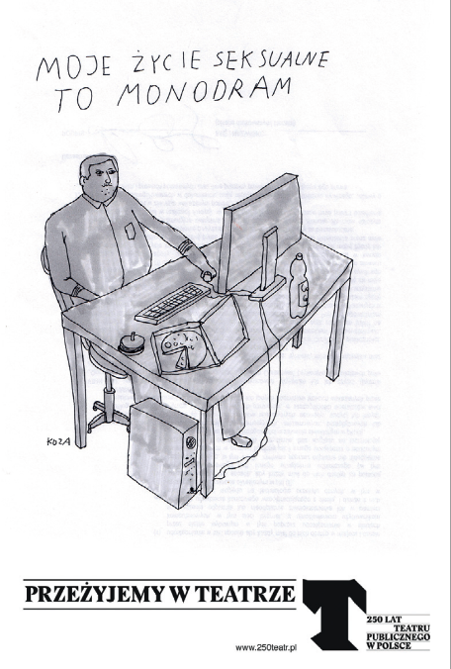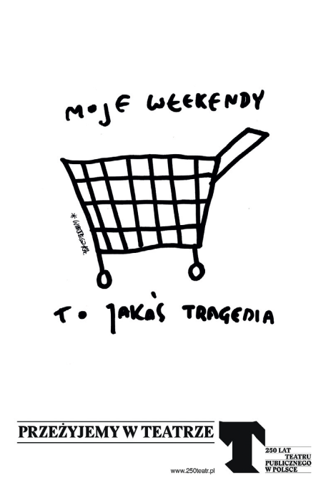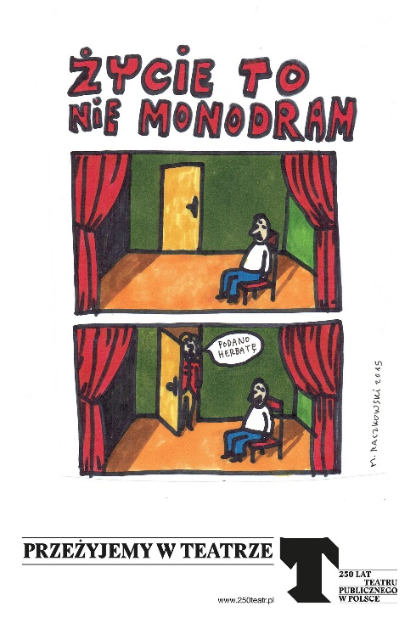

Another element of the “theatre’s venturing out into urban space” will be a series of artistic murals in various cities. One of them was part of inauguration of the celebrations in Kraków. Subsequent ones – this time in Warsaw and in Wrocław – will be painted by Jakub Woynarowski, laureate of the Paszport Polityki (Politka’s Passport) and Sławomir Zbiok Czajkowski.

Warsaw Book Fair
Celebrations of the jubilee of 250 YEARS OF PUBLIC THEATRE will also be one of the themes of this year’s 6th Warsaw Book Fair taking place between 14th and 17th May at the National Stadium. The Zbigniew Raszewski Theatre Institute took honorary patronage over the Fair.
As part of the jubilee, we will present the publishing offer of several publishing houses and a wealth of literary and historic narratives about the old and the contemporary Polish theatre. Moreover, we will organize a series of theatre workshops, an exhibition, multimedia lectures and performances.

Theatre walks
The spring and summer edition of celebrations encompasses also “Theatre walks”, organized from June onwards, for city dwellers, guided by city guides as well as well-known and acknowledged artists.
Proposed routes should – thanks to their unconventional and attractive formula – encourage people to do sightseeing and to learn the theatrical, and thus cultural, history of cities. In Warsaw, we wish to follow the path of outstanding personalities of the Polish theatre, visit cafes frequented by artists and writers, and organize walks for children only.
Special information boards on selected theatre buildings will provide descriptions of places (contemporary as well as historical ones) of particular importance for the history of theatre. There will be around 40 such boards. Each of them will have a QR code linked to a website with broader description of the place (with photos).

Other projects
Projects coordinated by the Theatre Institute within the framework of celebrations of 250 YEARS OF PUBLIC THEATRE IN POLAND will also encompass educational activities. We wish, however, to equip them with modern tools.
One of such projects is the “School theatrary”, i.e. an open and modern Internet platform for teachers and culture animators in Poland. It will contain didactic materials for primary and lower and upper secondary school teachers, grouped according to levels, methods of teaching and topics. Teachers will have access to lesson scenarios prepared according to original methodologies developed by practitioners who cooperated on that project, visual materials and fragments of performances serving as introduction to practical theatre activities with students.
The Theatre Institute is also conducting advanced works on a “Digital encyclopaedia of Polish theatre” - an Internet compendium of knowledge about theatre (all key information in one place and available free of charge for every user). Digital encyclopaedia is a platform integrating existing theatre resources, data bases and new archives, linked to an e-library and an e-reading room of magazines, enabling its users to use traditionally ordered knowledge and to create own histories through access to many narratives.
We will also be remind people why Polish public theatre is a unique phenomenon on the map of Europe through ten minutes long documentaries presenting selected events from the history of public theatre: from its inauguration in 1765 to generational change at the end of the 1990s. Individual episodes are built around chosen events, which constitute starting points to a presentation of related topics and problems – both historical and contemporary ones.
In cooperation with the Polskie Radio Program II (II Progamme of the Polish Radio), the Zbigniew Raszewski Theatre Institute is also preparing two cycles of radio programs to be broadcast throughout the whole 2015: 250 YEARS OF PUBLIC THEATRE IN POLAND – a Friday program broadcast biweekly, from September 2014 onwards, with Maciej Nowak as its host – and “The Encyclopaedia of Polish Theatre” – a daily program broadcast since January 2015.
In the autumn, we will present photos of laureates of the Theatre Photo Contest announced in 2014 by the Theatre Institute. Persons submitting their works compete in two categories: photo documenting the process of preparation and the resulting performance, and in the “Theatre photo of the season” category, which gives photographers full freedom of interpretation of that topic.
Celebrations of the jubilee will also be accompanied by virtual exhibitions prepared together with Google Cultural Institute (already today, on www.250teatr.pl two of them can be visited: “Polish public theatre. 1765–2015” and “250 years of National Theatre”), and discussion panels and debates focusing on public theatre.
One of the most important events targeted at foreign audiences will be the international scientific and artistic showcase “Polska New Theatre” organized by the Ministry of Foreign Affairs, the Zbigniew Raszewski Theatre Institute and the Hieronim Konieczka Polish Theatre in Bydgoszcz, which will take place between 25 and 27 September 2015. Young curators, researchers and artists from all over the world will participate in it. Specially tailored agenda presenting performances of young Polish directors will provide many opportunities to meet and discuss the key problems tackled by theatre irrespective of longitude. Lectures, presentations and workshops will be prepared for showcase participants.
In the autumn, an international conference on the role and importance of national theatres in the world will be organized in National Theatre.
A year ago, at the Theatre Institute – also during an international conference – a discussion about different models of theatre production in Europe and analysis of their impact on artistic shape of performances was started (the meeting was organized with the General Representation of the Government of Flanders in Poland and the Office of Culture of the capital city of Warsaw). The discussion commenced then will be continued in 2015 during the celebrations of 250 YEARS OF PUBLIC THEATRE IN POLAND.

Finale of the celebrations
Beginnings of the history of institutional public theatre go back to the premiere of Józef Bielawski’s “Intruders” (“Natręci”) (one evening in November of 1765). This is why it is for November - and to be more precise, for 28th November – that we planned the final of the Contest for Stage Production of Old Works of Polish Literature inaugurated in September 2013 entitled “Living Classics”, which will be at the same time the official closing celebration of 250th ANNIVERSARY OF PUBLIC THEATRE IN POLAND.
Within the framework of the call for projects, which ended a year ago, the Ministry of Culture and National Heritage co-financed 22 performances, which automatically entered the ongoing contest for stage productions. The latter is still open for stage productions of Polish texts created before 1969, i.e. the year of Witold Gombrowicz’s death, the premiere of which took/will take place between 26th September 2013 and 31st August 2015.
Premieres of “Living Classics” take place continuously: in March it was for instance “Forefathers’ Eve” (“Dziady”) directed by Paweł Passini in the Alojzy Smolka Puppet and Actor Theatre in Opole and “Akropolis” directed by Anna Augustynowicz in the Contemporary Theatre in Szczecin.
On 28th November, during the grand finale of “Living Classics”, all contest performances will be presented. On that day, moreover, individual and team prizes will be awarded, as well as the Wojciech Bogusławski main prize, to be used for execution of repertoire item selected by the winner until the end of the 2016/17 season, as well as the Stanisław Hebanowski special prize for the most interesting discovery of the festival. Moreover, recommendations of performances to be presented during a selected theatre festival in 2016 will be made.
We wish to remind the audience about performances of “Living Classics” in unusual locations – for instance in PKP Intercity trains bearing names of the most outstanding authors (for example Express IC train Wyspiański). We plan to arrange there „stages” of chamber performances and improvised etudes inspired with classical repertoire. Transferring theatre to trains in that way, we want not only to show that our classics can really be living, but also to dispel the myth of elitism and exclusivity of theatre.

Detailed information and current contest news may be found at www.klasykazywa.pl.

Celebrations of the jubilee of 250 YEARS OF PUBLIC THEATRE IN POLAND are accompanied by daily updated and expanded website www.250teatr.pl. It presents i.a. descriptions of projects and links to dedicated websites, calendar of events, virtual exhibitions, radio programs and other related materials.

